Electronics components practical and measurements with multi-meter
This practical focuses on identifying resistor values using colour codes (4-band or 5-band) and verifying them using a digital multi-meter (DMM) to compare nominal (coded) versus measured resistance.

Lab Objectives
- The aim of this experiment is to learn how to use the multi-meter and how to calculate the value of the resistor.
- Identify resistor values using colour bands.
- Measure actual resistance using a digital multi-meter (ohmmeter).
- Understand tolerance (e.g., Gold ±5%, Silver ±10%) and its impact on resistance range.
- Compare theoretical colour-coded values with actual measured values.
Component Required
- Set of resistors
- 10 multi-meters for 80 students
Theory
A passive electrical component with two terminals that are used for either limiting or regulating the flow of electric current in electrical circuits. The main purpose of resistor is to reduce the current flow and to lower the voltage in any particular portion of the circuit. It is made of copper wires which are coiled around a ceramic rod and the outer part of the resistor is coated with an insulating paint.
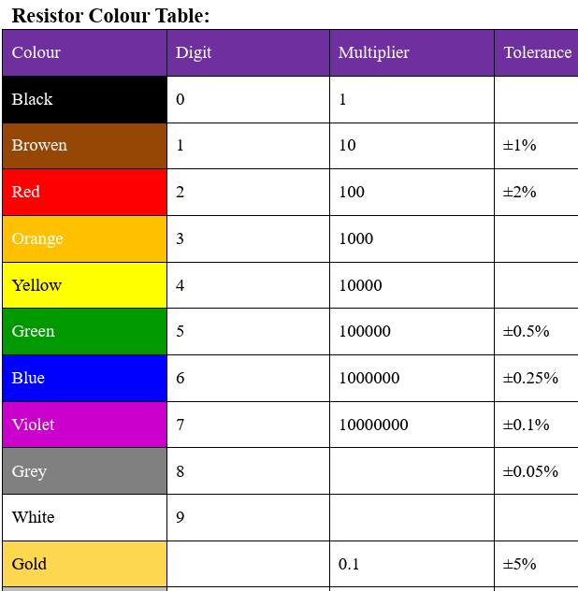
Tolerance: Tolerance indicates how much the measured value of its actual resistance is different from its theoretical value, and it is calculated using percentages.

How to Read Resistor Colour Code?
- To read them, hold the resistor such that the tolerance band is on your right. The tolerance band is usually gold or silver in colour and is placed a little further away from the other bands.
- Starting from your left, note down all the colours of the bands and write them down in sequence.
- Next, use the table given to see which digits they represent.
- The band just next to the tolerance band is the multiplier band. So if the colour of this band is Red (representing 2), the value given is ${10}^{2}$.

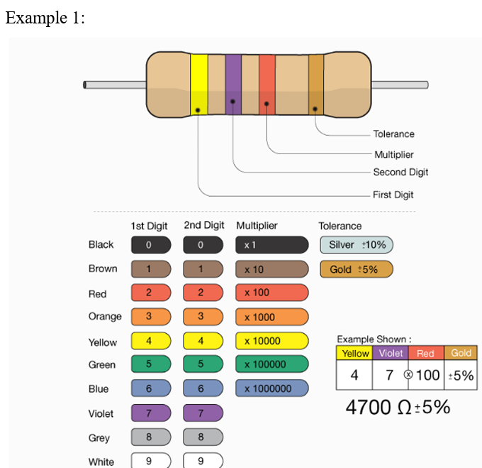

Resistor Colour Code Procedure
- Identify the orientation: The tolerance band (gold/silver) is typically held to the right, with the first band on the left representing the first significant digit.
- Read the digits:
- 1st Band: First Significant Digit.
- 2nd Band: Second Significant Digit.
- 3rd Band: Multiplier (${10}^{n}$, where n is the colour code number)
- 4th Band: Tolerance Percentage.
- Example (4-band): Brown-Black-Red-Gold
- Brown (1), Black (0), Red (2), Gold (5%)
- 1 0 x ${10}^{2}$=1000 =1k$Ω±5\%$
Digital Multi-meter:
A digital multi-meter is a test tool used to measure two or more electrical values— principally voltage (volts), current (amps) and resistance (ohms). It is a standard diagnostic tool for technicians in the electrical/electronic industries.

How to use a multi-meter
Digital multi-meters combine the testing capabilities of single-task meters—the voltmeter (for measuring volts), ammeter (amps) and ohmmeter (ohms). Often, they include several additional specialized features or advanced options. Technicians with specific needs, therefore, can seek out a model targeted to meet their needs.

The face of a multimeter typically includes four components: • Display: Where measurement readouts can be viewed. • Buttons: For selecting various functions; the options vary by model. • Dial (or rotary switch): For selecting primary measurement values (volts, amps, ohms). • Input jacks: Where test leads are inserted.

Test leads are flexible, insulated wires (red for positive, black for negative) that plug into the DMM. They serve as the conductor from the item being tested to the multi-meter. The probe tips on each lead are used for testing circuits.

Measuring Voltage
- Plug the test leads into the COM and V terminals. Always plug the black test lead into the terminal that’s labelled "COM" for "Common." Always plug the red test lead into the terminal labelled "V" for "Voltage," since this is what you’re testing.
- Move the dial to the voltage setting for AC or DC voltage. Turn the dial to V~, or the V with a wave sign next to it, if you’re measuring AC voltage. Switch the dial to V⎓, or the V with a horizontal line next to it, to measure DC voltage.
- Set the voltage range to a higher voltage than what’s expected. If you set the voltage range too low, you won’t get an accurate reading. Look at the numbers on the dial and choose the setting that’s closest to the expected voltage of what you’re measuring, while still being above that voltage.

- Touch the probes to both sides of a load or power source. Put the tip of the black probe on the negative lead of a battery or into the right side of a wall socket, for example. Put the red probe on the positive end of a battery or into the positive side of a wall socket, for instance

Measuring Resistance:
- Insert the black test lead in COM and the red test lead in the Ω terminal. Stick the black test lead’s plug into the COM terminal. The red test lead’s plug goes into the terminal labelled Ω, which is the symbol for ohms.
- Set the dial to a number on the multi-meter’s resistance scale. Look for the Ω symbol on your multi-meter’s dial area. Twist the dial to a number close to the expected resistance in this section. If you aren’t sure what the expected resistance is, set it to a number at the top of the scale.
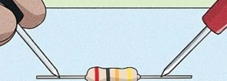
- Place the probes on the resistor and read the resistance. Touch the tips of the probes onto each end of the resistor. Look at the multi-meter’s digital screen to see the reading, which tells you the amount of resistance in ohms
Experiment procedure: 1- Choose randomly three different resistors. 2- Read the resisters value by using resistor colour code method. 3- Using the multi-meter, read the resistors value (Measured value). 4- Write down all the measured and calculated values on the table below.
Assignment
You pick a printed circuit board from an old computer. You see a resistor with colour bands: Red – Violet – Orange – Gold.
- What multi-meter setting and probe placement would you use to verify its value?
- What resistance should you expect to read (including tolerance)?
- If you measure 27 kΩ instead, what could be wrong?

